Instrument status list
Client's name |  |  | Instrument name | MLS045 instrument
NO. | project |  | Function parameter
 | Operating Voltage |  | DC12V。
 | Shutdown gate, standby power consumption |  | Less than 4mA。
 | Speedometer |  | The tire has a circumference of 1.85 meters and two magnetic steels in one circle.  LCD display, 36Hz = 63KM / H; when there is a speed, the speed signal lights begin to flow.
 | Tachometer |  | Liquid crystal display, 166 Hz vs. 10 x 1000 r/min.
 | Fuel gauge |  | LCD display, with fuel sensor, fuel block display, no display.  Piece 0 block, E, F, tanker symbol flash 1 flash, oil pot flash 1 block 2 pieces 3 blocks 4 blocks 5块  2-wire requirement More than 90 89－81 80－71 70－53 52－34 33－15 14以下
 | Water temperature gauge |  | The liquid crystal display is connected with a water temperature sensor, and the water temperature block is long and does not display.  Piece 0 block 1 block 2 pieces 3 blocks 4 blocks 5 full flashes  Resistance（Ω） 699-558 euro 557-194 euro 193-137 euro 136－126 euro 125－83 euro 82 euro
 | Undervoltage alarm |  | no.
 | Key Function |  | A. Short press the button, total (ODO), subtotal (TRIP) switching.  B. In the total (ODO) interface, press and hold the button for 8 seconds, the metric system switches, the default is in metric system, after switching, it can be saved even if it is completely powered off.  C. In the subtotal (TRIP) interface, press and hold the button for 4 seconds, and the subtotal is cleared.  D. In the total (ODO) interface, press and hold the button for 4 seconds to release, enter the clock setting, the hour digit flashes, the second point does not flash, short press the button to add 1 long press the button for 3 seconds to switch to the quantize second flash, second Do not flash, then press and hold the button for 3 seconds to save or exit or 10 seconds without operation to automatically save and exit.
 | Clock adjustment |  | 12-hour system, cold boot AM10:00, in the total (ODO) interface, long press the button for 4 seconds to release, enter the clock setting, the hour flashes, the second does not flash, short press the button to add 1 long press the button 3 The second is switched to the minute second flash, the second point does not flash, and then the long press button for 3 seconds to save or exit or 10 seconds without operation to automatically save and exit.
 | Backlight |  | LCD backlight: white.
 | LCD screen |  | 6 o'clock.
 | sensor
 | 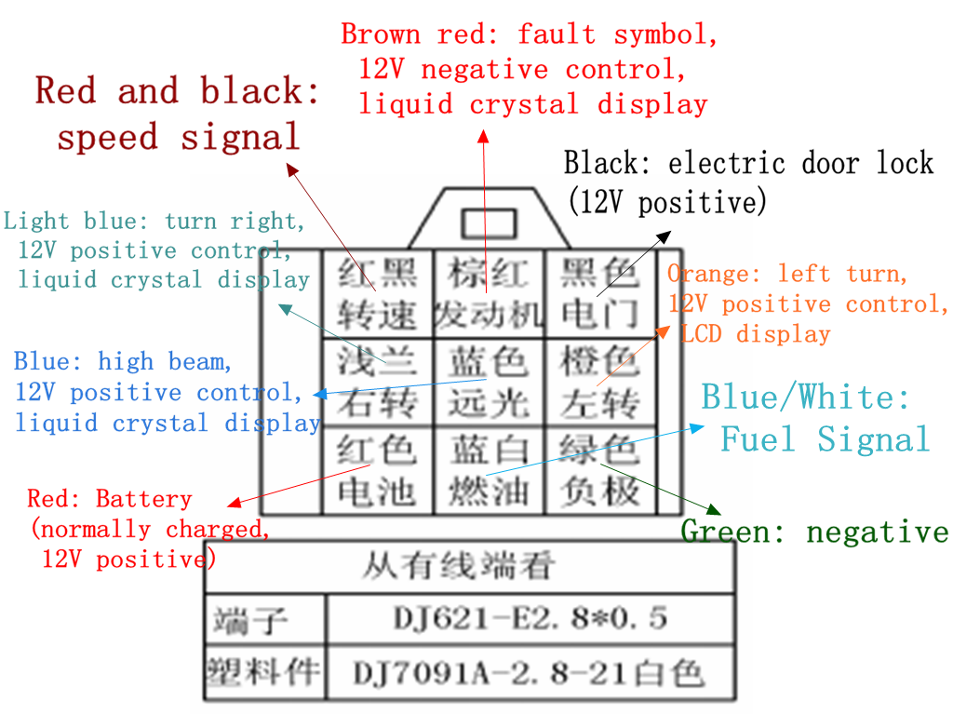 |  |  |  | Red and black: speed signal  Brown red: fault symbol, 12V negative control, liquid crystal display  Black: electric door lock (12V positive)  Light blue: turn right, 12V positive control, liquid crystal display  Blue: high beam, 12V positive control, liquid crystal display  Orange: left turn, 12V positive control, LCD display  Red: Battery (normally charged, 12V positive)  Blue/White: Fuel Signal  Green: negative
 | 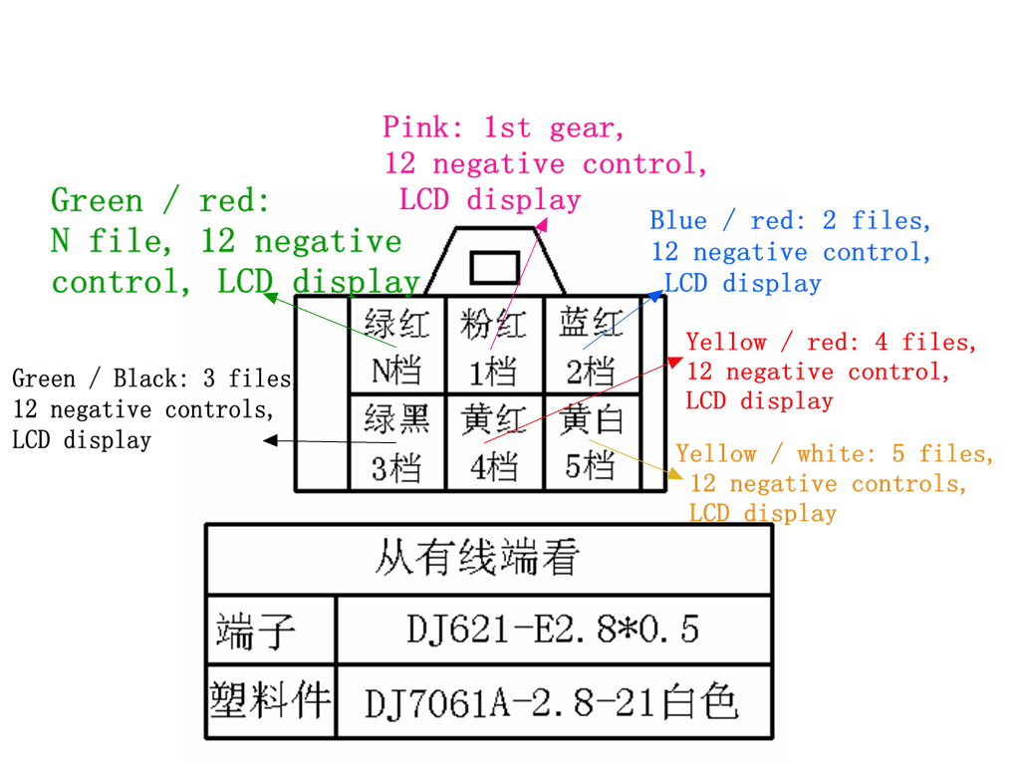 |  |  |  | Green / red: N file, 12 negative control, LCD display  Pink: 1st gear, 12 negative control, LCD display  Blue / red: 2 files, 12 negative control, LCD display  Green / Black: 3 files, 12 negative controls, LCD display  Yellow / red: 4 files, 12 negative control, LCD display  Yellow / white: 5 files, 12 negative controls, LCD display
 | Φ4 round head |  |  |  | Gray: 6 files, 12 negative controls, LCD display  Green and white: water temperature signal  Brown: backlight control, 12V positive control,  When the backlight is turned on, the backlight brightness is reduced from 100% to 30%.
 | 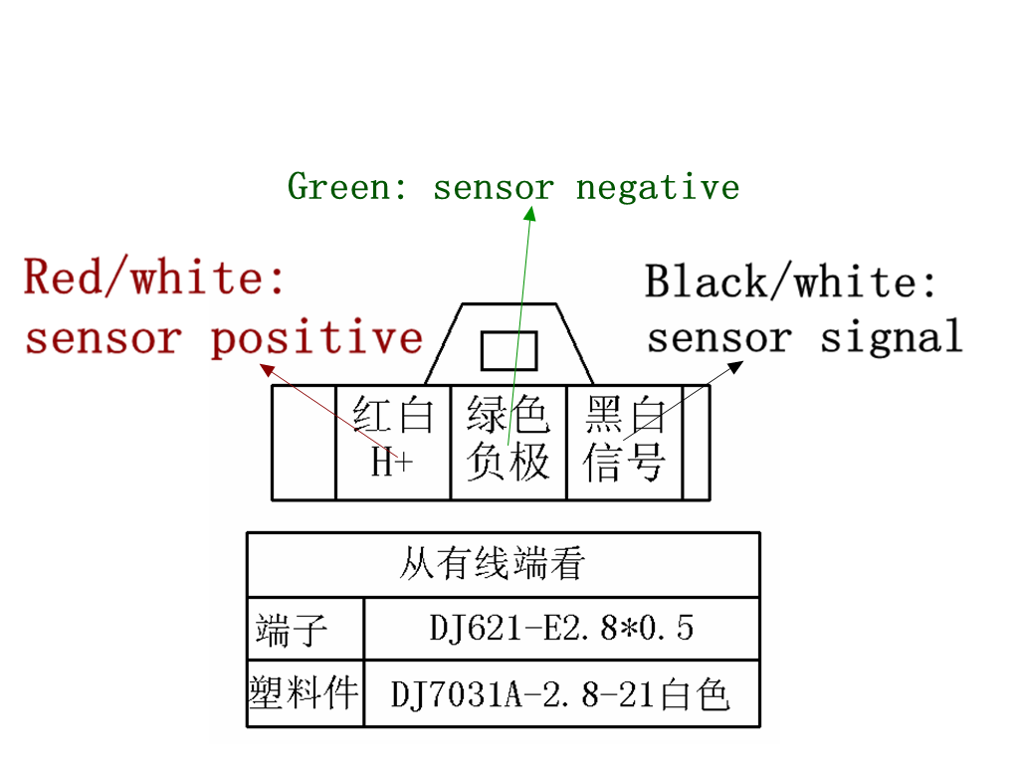 |  |  |  | Red/white: sensor positive  Green: sensor negative  Black/white: sensor signal

Background parameter setting

  - First press and hold the button, then open the electric door lock, 5s enters the back door setting, divided into 6 interfaces
  - Interface 1: Tire circumference value setting
The first 8 digits of the speed display 188 shows 1, the total cumulative display C-1850, 1850 means the default tire circumference is 1850mm, thousands of flashes, short press the button to modify, 5s no operation, hundreds of flashes, cycle to a single position, (Go jump to thousands of places to flash). The circumference can be set from 500-2600mm, long press the button for 3 seconds to save and enter the magnet steel number setting interface.

  - Interface 2：Magnetic steel number setting
The first 8 digits of the 188 display of the speed display 2, the total cumulative display C---02, 02 indicates the number of magnetic steel, 1-12 can be set, short press the button to modify. Press and hold the button for 3 seconds to enter the speed setting interface.

  - Interface 3：Speed setting interface
The first 8 digits of the 188 display of the vehicle speed display 3, the total cumulative display C----2, 2 indicates that the engine is 2 cylinders. Short press the button to switch between 2 and 4 cylinders. Press and hold the button for 3 seconds to save the two-line and three-line fuel setting interface.

  - Interface 4：Two-line three-line fuel setting（Two lines and three lines in the general item of the upper computer should be set）
The first 8 digits of the speed display 188 shows 4, the total cumulative display E----2, 2 indicates the second-line oil meter, set to 3-line display E----3, set to 2-line display E---- 2. Short press the button to switch between 3 lines/2 lines. Press and hold the button 3s to save to enter the cumulative clear interface.

  - Interface 5：Metric system setting（At this point, there must be a common setting item on the host computer.）
The 188 first digit of the speed display shows 5, the lower right corner shows km/h, and the short press km/h and mph switch. Press and hold the button for 3 seconds to save the mileage clearing interface. Default km/h

  - Interface 6：Cumulative clear
The first 8 digits of the 188 display of the speed display 6, short press the button to clear, once clear 200km, can be cleared three times (into the back door set to clear once) long press or power down to exit the back door setting.

